**MP Practical- 6**

Name- Siddhesh Dilip Khairnar

Roll No.- 272028

Batch- B2

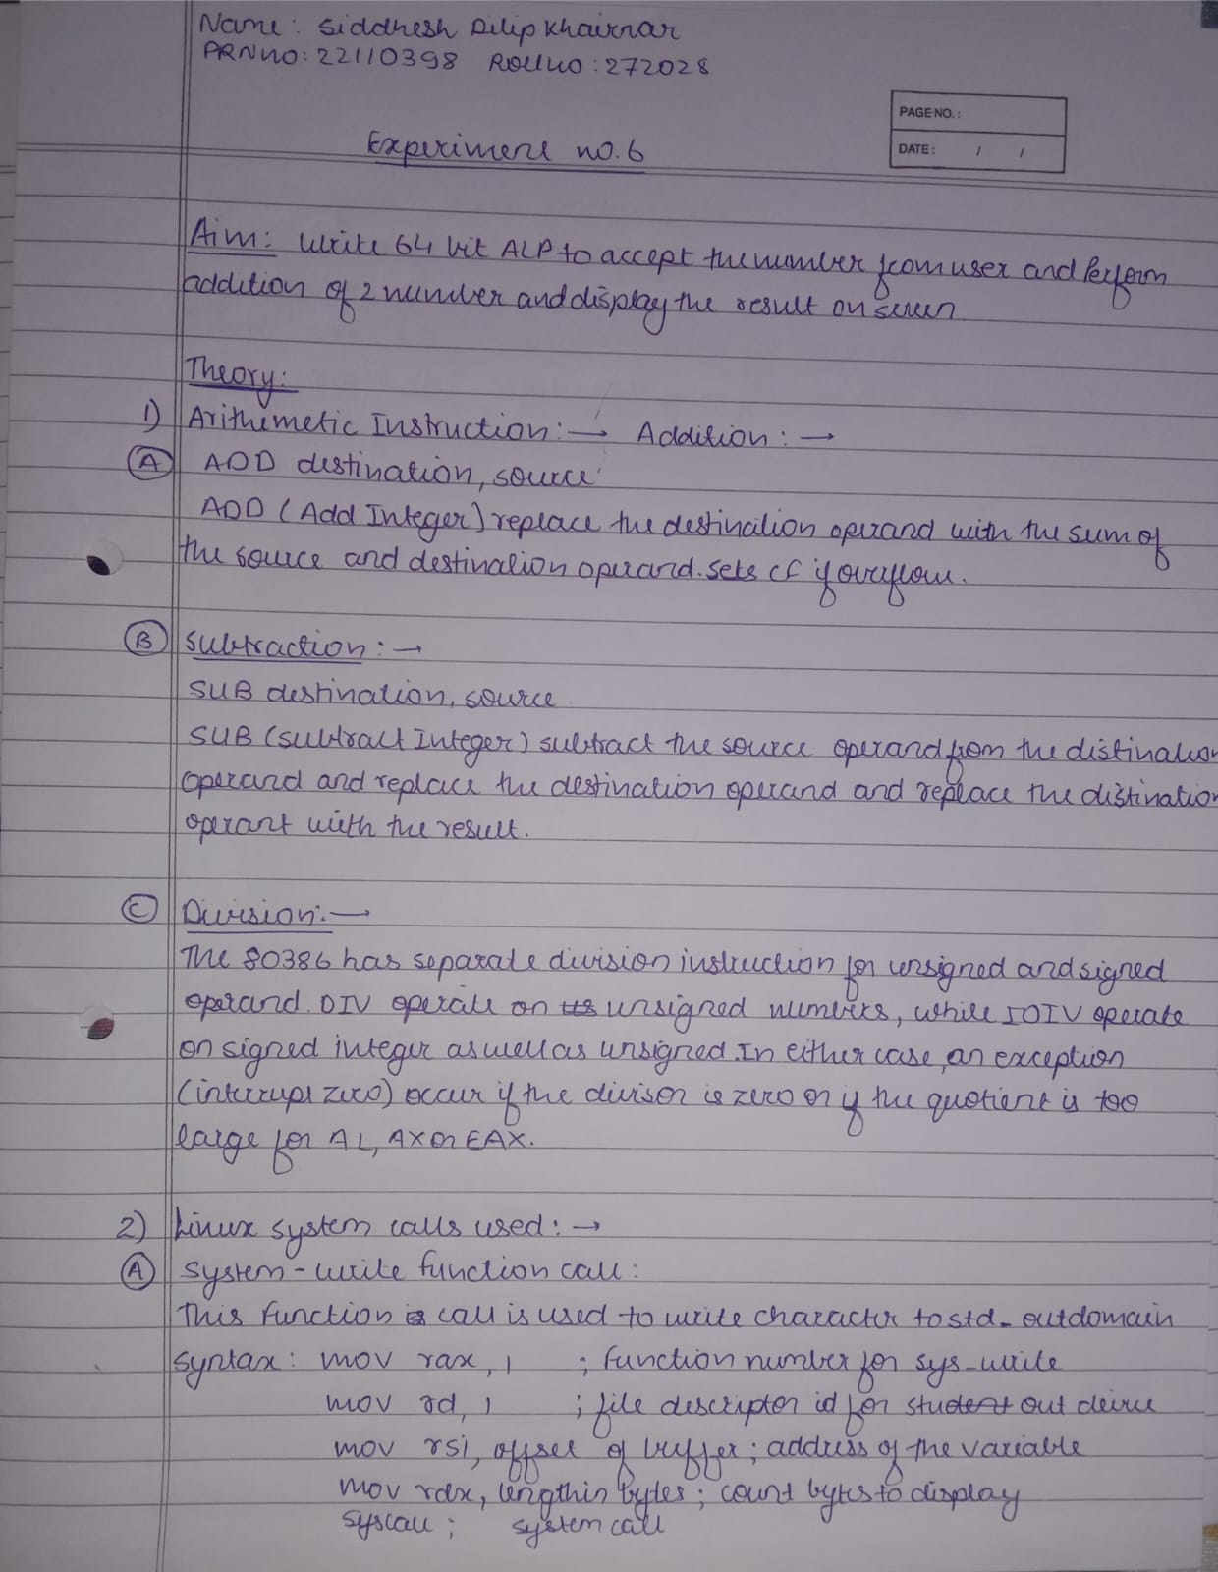

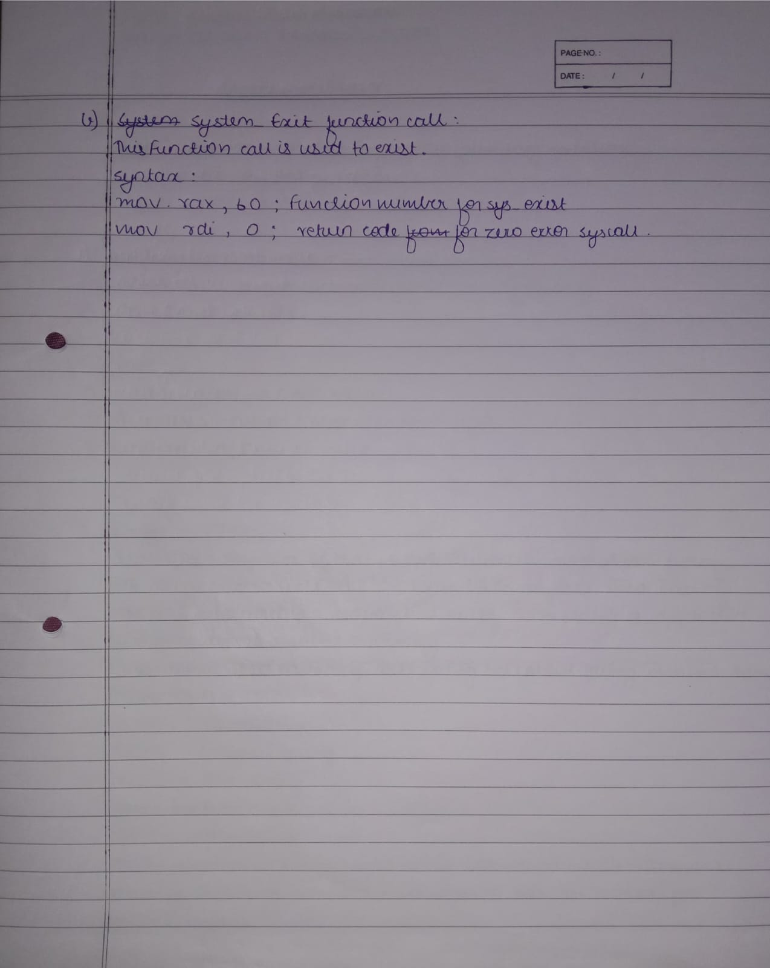

**Code:**

%macro scall 4

mov rax,%1

mov rdi,%2

mov rsi,%3

mov rdx,%4

syscall

%endmacro

section .data

m1 db "Enter first 2digit number=",10d,13d

l1 equ $-m1

m2 db "The 1 is =",10d,13d

l2 equ $-m2

m3 db "",10d,13d

l3 equ $-m3

m4 db "Enter second 2digit number=",10d,13d

l4 equ $-m4

m5 db "The 2 is =",10d,13d

l5 equ $-m5

m6 db "Sum is =",10d,13d

l6 equ $-m6

section .bss

num resb 20

array resb 200

char_ans resb 16

section .text

global _start

_start:

;--------------------first number-------------------------

scall 1,1,m1,l1

scall 0,0,num,3

call accept_proc

mov rbp,array

mov [rbp],bx

scall 1,1,m2,l2

mov ax,bx

call display_proc

inc rbp

;-----------------------second number-----------------------------

scall 1,1,m4,l4

scall 0,0,num,3

call accept_proc

mov [rbp],bx

scall 1,1,m5,l5

mov ax,bx

call display_proc

;----------------------sum---------------------

mov rbp,array

mov dx,[rbp]

add bx,dx

inc rbp

mov cx,[rbp]

add bx,cx

scall 1,1,m6,l6

mov ax,bx

call display_proc

;----------------------exit---------------------

mov rax,60

mov rdi,0

syscall

;-----------------------accept procedure--------------------

accept_proc:

mov rsi,num

mov rbx,0

mov rax,0

mov rcx,2

back:

rol rbx,04

mov al,[rsi]

cmp al,39h

jbe next

sub al,07h

next:

sub al,30h

add bx,ax

inc rsi

dec rcx

jnz back

ret

;-----------------dispaly procedure-----------------------------

display_proc:

mov rbp,char_ans

mov rcx,2

up3:

rol al,04

mov dl,al

and dl,0Fh

cmp dl,09h

jbe next1

add dl,07h

next1:

add dl,30h

mov [rbp],dl

inc rbp

dec rcx

jnz up3

scall 1,1,char_ans,3

scall 1,1,m3,l3

ret

**Output:**

